**IT332L – FINAL ACTIVITY**

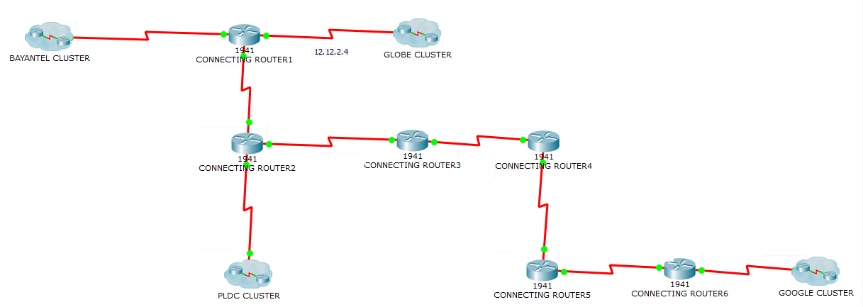

Please refer to the figure above for the CLUSTER SETUP.

There are 4 different clusters connected together using a 1941 connecting routers. All of them are connected using a serial cable. Each cluster are simulating an ISP CLOUD that host various clients.

The IP ADRESS SPACE for this connection is 12.12.2.0. Apply an addressing scheme that conserves the most amount of addresses or future growth.

**BAYANTEL CLUSTER**

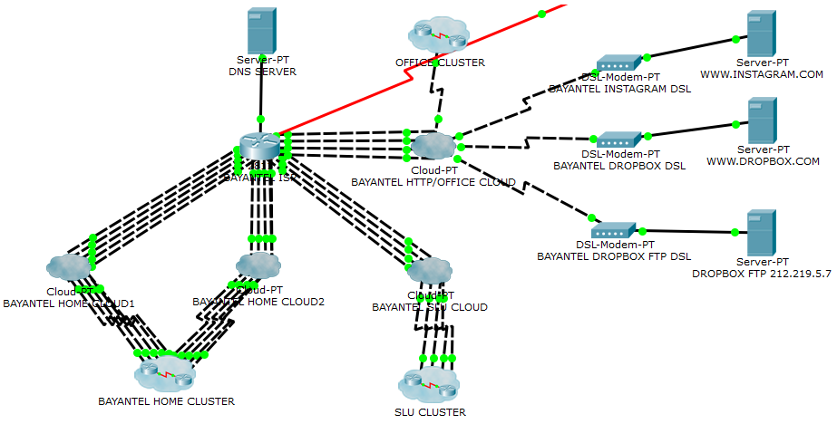

Please refer to the figure above for the BAYANTEL ISP CLOUD SETUP.

The BAYANTEL ISP services 4 different clusters: HOME CLUSTER, SLU CLUSTER, OFFICE CLUSTER, 2 HTTP SERVERS AND AN FTP SERVER. BAYANTEL ISP IP address space: 212.219.5.0 /24. Apply a configuration on BAYANTEL ISP ROUTER that will allow it to broadcast IP Addresses using the 212.219.5.0 space on the different clients connected to it. Apply a configuration that will also allow the ISP router to give a DNS for the different HTTP servers.

DROPBOX FTP username and password: cisco cisco.

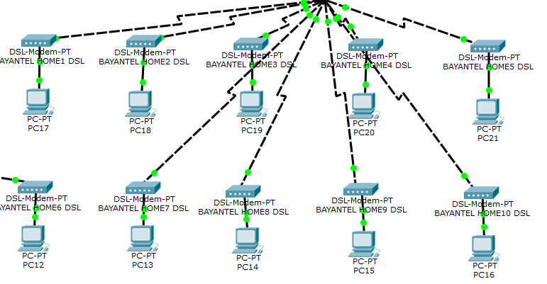

Please refer to the figure above for the BAYANTEL HOME CLUSTER SETUP.

BAYANTEL HOME CLUSTER is just a simple setup with 10 END DEVICES connected to 10 DSL MODEMS.

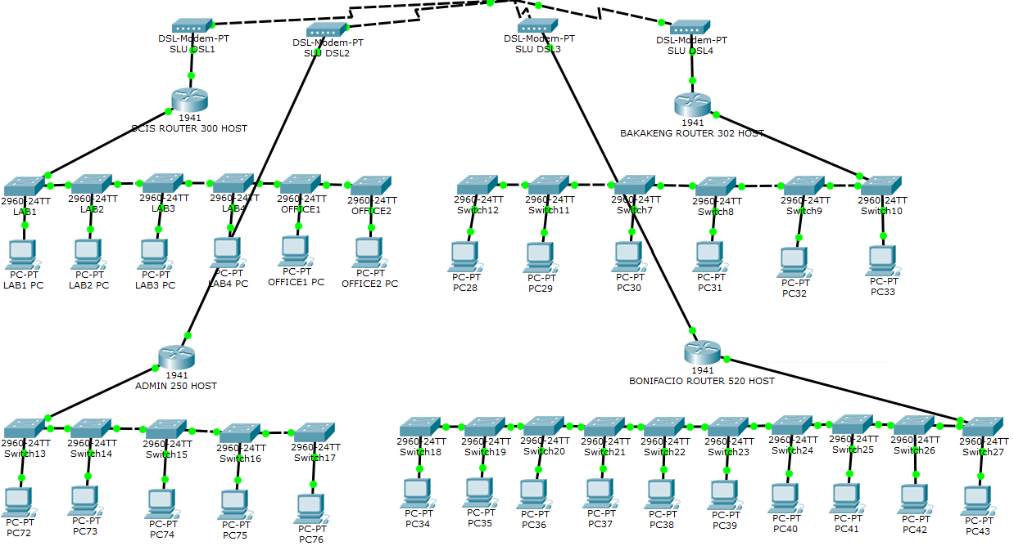

Please refer to the figure above for the BAYANTEL SLU CLUSTER SETUP.

THE SLU CLUSTER has 4 routers that are connected to 4 DSL modems: SCIS, BAKAKENG, ADMIN, and BONIFACIO. SCIS ROUTER needs a network for 300 host, BAKAKENG for 302 host, ADMIN for 250 host and BONIFACIO is 520 host. All routers are DHCP enabled.

The IP ADDRESS SPACE is 10.10.16.0 /20. Apply an addressing scheme that conserves the most amount of addresses for future growth.

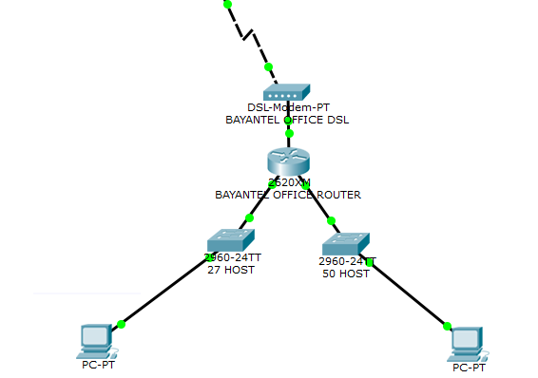

Please refer to the figure above for the BAYANTEL SLU CLUSTER SETUP.

Just a simple office setup. DHCP enabled. The IP ADDRESS SPACE is 192.168.1.0 /24. Apply an addressing scheme that conserves the most amount of addresses for future growth.

**PLDC CLUSTER**

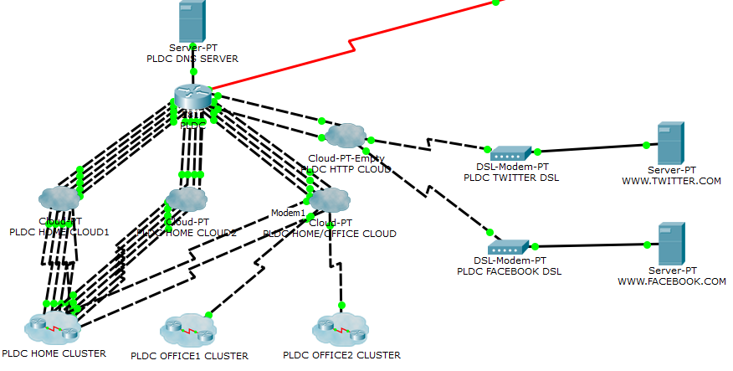

Please refer to the figure above for the PLDC ISP CLOUD SETUP.

The PDLC ISP services 4 different clusters: HOME CLUSTER, OFFICE1 CLUSTER, OFFICE2 CLUSTER and 2 HTTP SERVERS. BAYANTEL ISP IP address space: 172.16.6.0 /24. Apply a configuration on PLDC ISP ROUTER that will allow it to broadcast IP Addresses using the 172.16.6.0 space on the different clients connected to it. Apply a configuration that will also allow the ISP router to give a DNS service for the different HTTP servers.

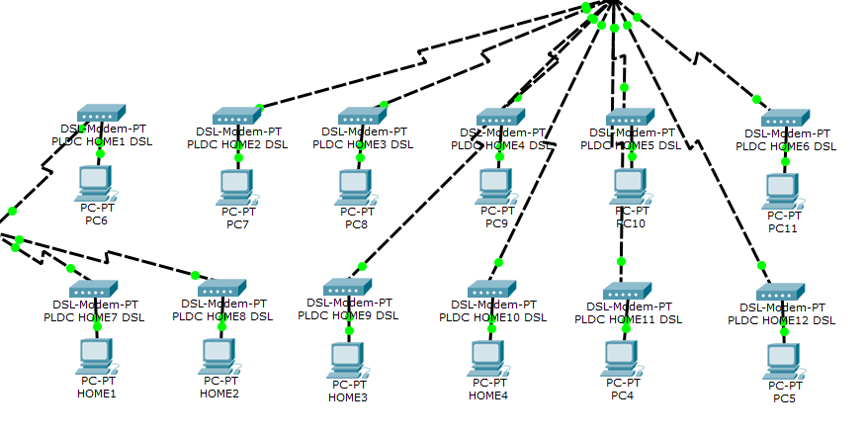

Please refer to the figure above for the PLDC HOME CLUSTER SETUP.

PLDC HOME CLUSTER is just a simple setup with 12 END DEVICES connected to 12 DSL MODEMS.

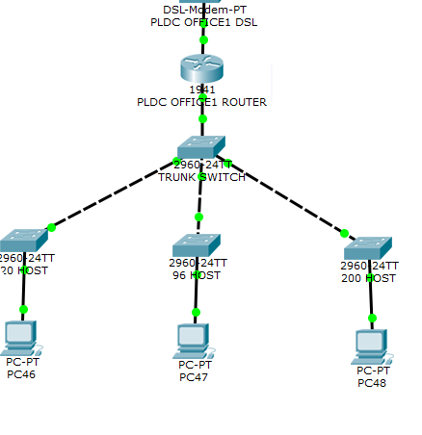

Please refer to the figure above for the PLDC OFFICE1 CLUSTER SETUP.

THE OFFICE1 CLUSTER has 1 router and 4 switches that is configured as INTER-VLAN network. DHCP enabled.

The IP ADDRESS SPACE is 192.168.1.0 /23. Apply an addressing scheme that conserves the most amount of addresses for future growth.

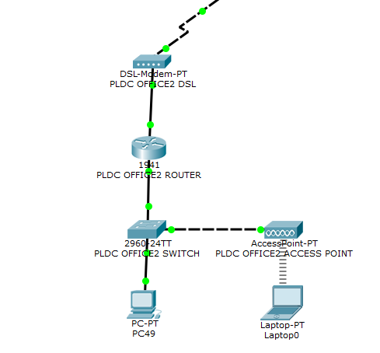

Please refer to the figure above for the PLDC OFFICE2 CLUSTER SETUP.

THE OFFICE2 CLUSTER has a simple setup. 1 router, 1 switch and 1 access point. DHCP enabled.

The IP ADDRESS SPACE is 192.168.1.0 /24

**GLOBE CLUSTER**

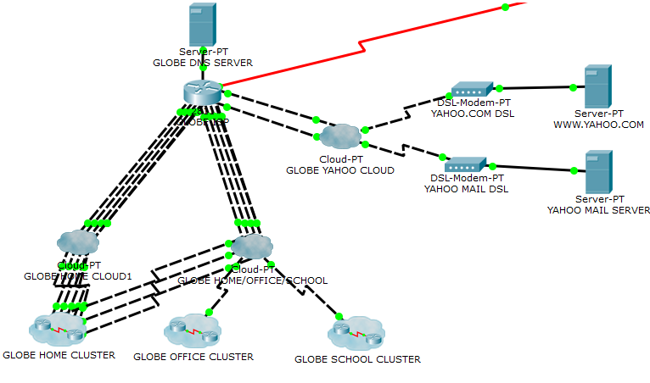

Please refer to the figure above for the GLOBE ISP CLOUD SETUP.

The GLOBE ISP services 4 different clusters: HOME CLUSTER, OFFICE CLUSTER, SCHOOL CLUSTER, 1 HTTP SERVER and a MAIL SERVER. BAYANTEL ISP IP address space: 121.96.170.0 /24. Apply a configuration on GLOBE ISP ROUTER that will allow it to broadcast IP Addresses using the 121.96.170.0 space on the different clients connected to it. Apply a configuration that will also allow the ISP router to give a DNS service for the different HTTP servers.

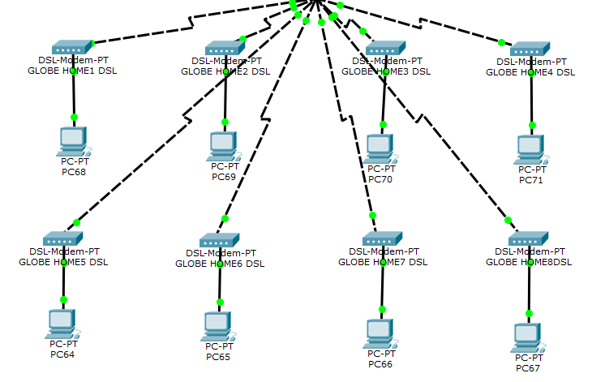

Please refer to the figure above for the GLOBE HOME CLUSTER SETUP.

GLOBE HOME CLUSTER is just a simple setup with 8 END DEVICES connected to 8 DSL MODEMS.

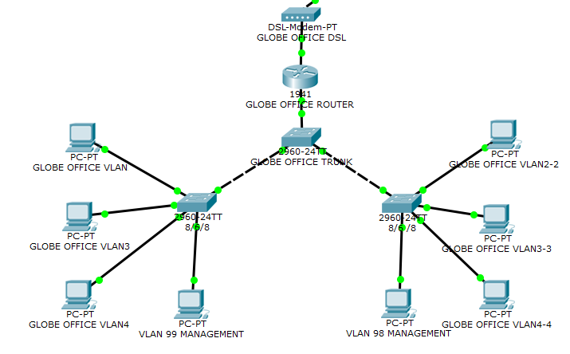

Please refer to the figure above for the GLOBE OFFICE CLUSTER SETUP.

The OFFICE CLUSTER has 1 router connecting it to the WAN, 1 trunk switch and 2 switches connecting 4 end devices each. 1 end device for each switch is configured as MANAGEMENT VLAN. 3 end devices for each switch are configured as 3 different VLANs respectively. VLANs with different IDs cannot communicate with each other in this network. DHCP enabled.

1st end device for each switch = VLAN 1; 8 HOST; 8 PORTS

2nd end device for each switch = VLAN 2; 6 HOST; 6 PORTS

3rd end device for each switch = VLAN 3; 8 HOST; 8 PORTS

The IP ADDRESS SPACE is 192.168.1.0 /24. Apply an addressing scheme that conserves the most amount of addresses for future growth.

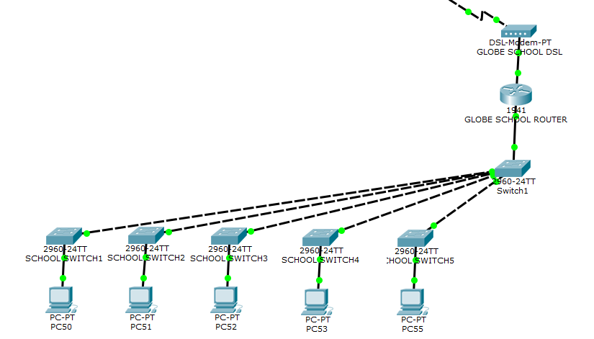

Please refer to the figure above for the GLOBE OFFICE CLUSTER SETUP.

THE SCHOOL CLUSTER has 1 router and 6 switches that is configured as INTER-VLAN network. DHCP enabled. 1 TRUNK SWITCH and 5 SWITCHES for each network.

The IP ADDRESS SPACES are 192.168.2.0, 192.168.3.0, 192.168.4.0, 192.168.5.0, 192.168.6.0

**GOOGLE CLUSTER**

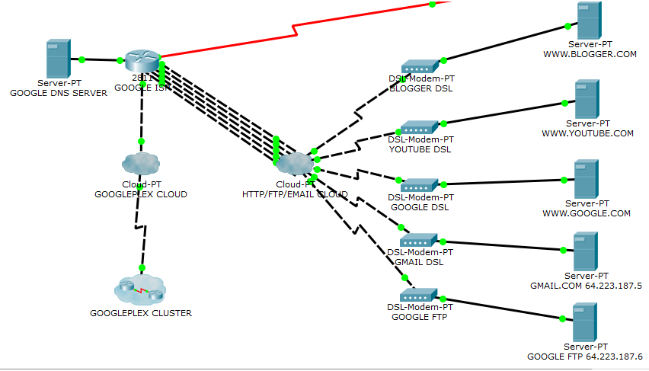

Please refer to the figure above for the GOOGLE ISP CLOUD SETUP.

The GOOGLE ISP services 2 different clusters: GOOGLEPLEX CLUSTER, 3 HTTP SERVER, 1 EMAIL SERVER AND 1 FTP SERVER. GOOGLE ISP IP address space: 64.223.187.0 /24. Apply a configuration on GOOGLE ISP ROUTER that will allow it to broadcast IP Addresses using the 64.223.187.0 space on the different clients connected to it. Apply a configuration that will also allow the ISP router to give a DNS service for the different HTTP servers.

GOOGLE FTP username and password: cisco cisco.s

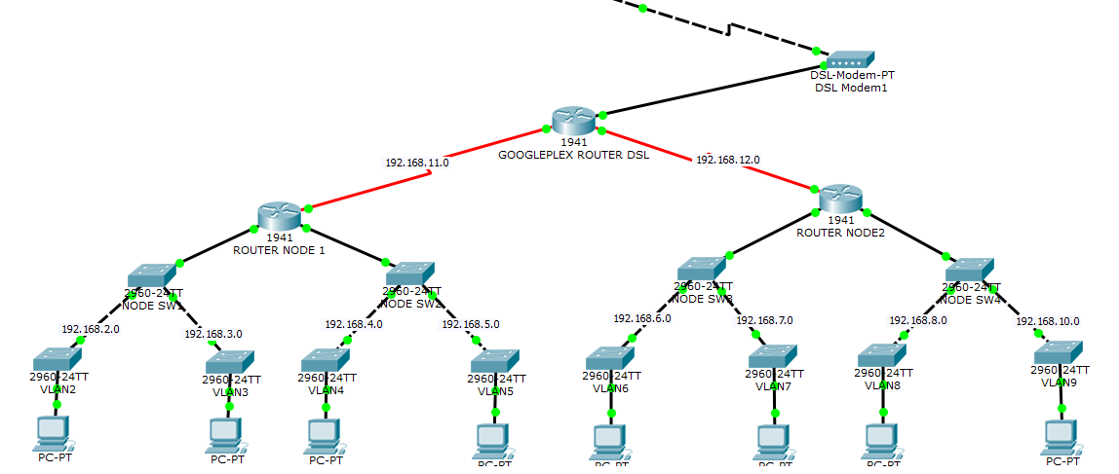

Please refer to the figure above for the GLOBE OFFICE CLUSTER SETUP.

THE GOOGLEPLEX CLUSTER is a network of VLANs. The GOOGLEPLEX ROUTER DSL is connected to the WAN and with 2 ROUTER NODES as well. This ROUTER NODES are used for INTER-VLAN routing and has 4 networks for each NODE as a total of 8 for the entire network. DHCP enabled.

The IP ADDRESS SPACES are noted in the figure.

**FINAL REQUIREMENT:**

ALL end devices can connect and use all the services (HTTP, EMAIL and FTP) configured on the entire network.